SIMATS ENGINEERING

CO3 – ASSESSMENT TOOL 1

Experiments

Course Name: Computer Networks
Course Code: CSA0706

Course Outcome Covered
CO3: Analyze the performance of core network protocols such as TCP, UDP, HTTP, and DNS under varying conditions.

Faculty: Dr.V.Parthipan
Assessment Tool Weightage: 40%

Code of Conduct

I DAKSHIN.S (192511431) certify that this submission is my original work and that I have adhered to the guidelines specified for this assessment.
I understand that any violation of academic integrity rules will result in disciplinary action.
Signature of the student: DAKSHIN.S

Criteria | Understanding of Concepts (2.5) | Experimental Design (3) | Use of Tools (2) | Analysis of Results (1.5) | Documentation (1) | Total (10)
Q1 | 2.5 | 3 | 2 | 1 | 1 | 9.5
Q2 | 2 | 3 | 2 | 1.5 | 1 | 9.5
Q3 | 2 | 3 | 2 | 1.5 | 1 | 9.5
Q4 | 2.5 | 2 | 2 | 1.5 | 1 | 9
Faculty Signature:

Experiments
1. Capture packets during a TCP connection setup. Identify the three packets involved in the handshake (SYN, SYN-ACK, and ACK). Demonstrate the role of each flag and how they establish a reliable connection. (BL4) (10)
2. Capture a DNS query using UDP in Wireshark. Compare the UDP header size with TCP and note the absence of sequence numbers or acknowledgments. Discuss how this lightweight design impacts speed and reliability. (BL4) (10)
.
3. Simulate packet loss (e.g., disconnect briefly) and capture traffic in Wireshark. Observe how TCP retransmits lost packets while UDP does not. Explain why this difference makes TCP reliable but slower compared to UDP. (BL4) (10)
4. Use Wireshark to capture DNS traffic while resolving a domain name. Identify the query type (A, AAAA, MX) and the response received. Measure the time taken for resolution and explain why DNS typically uses UDP. (BL4) (10)

Question 1
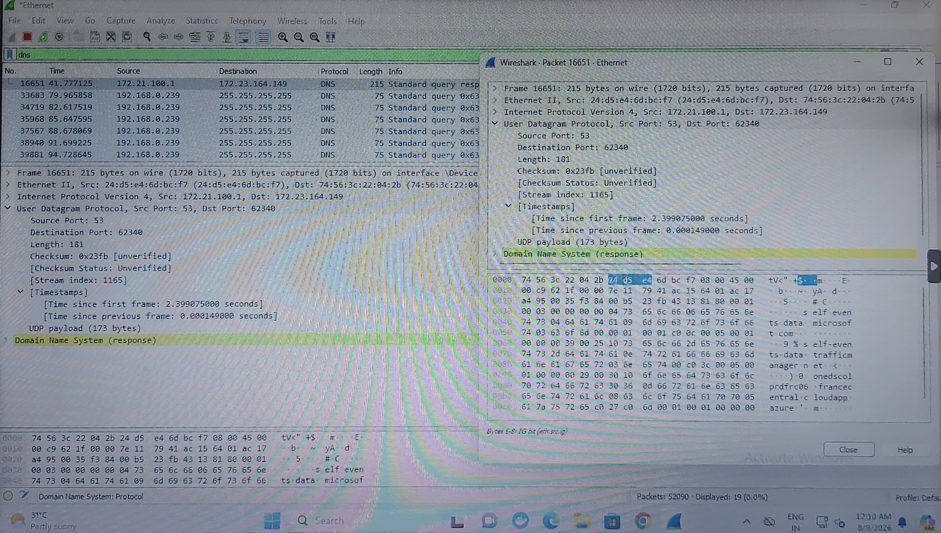
Question 2 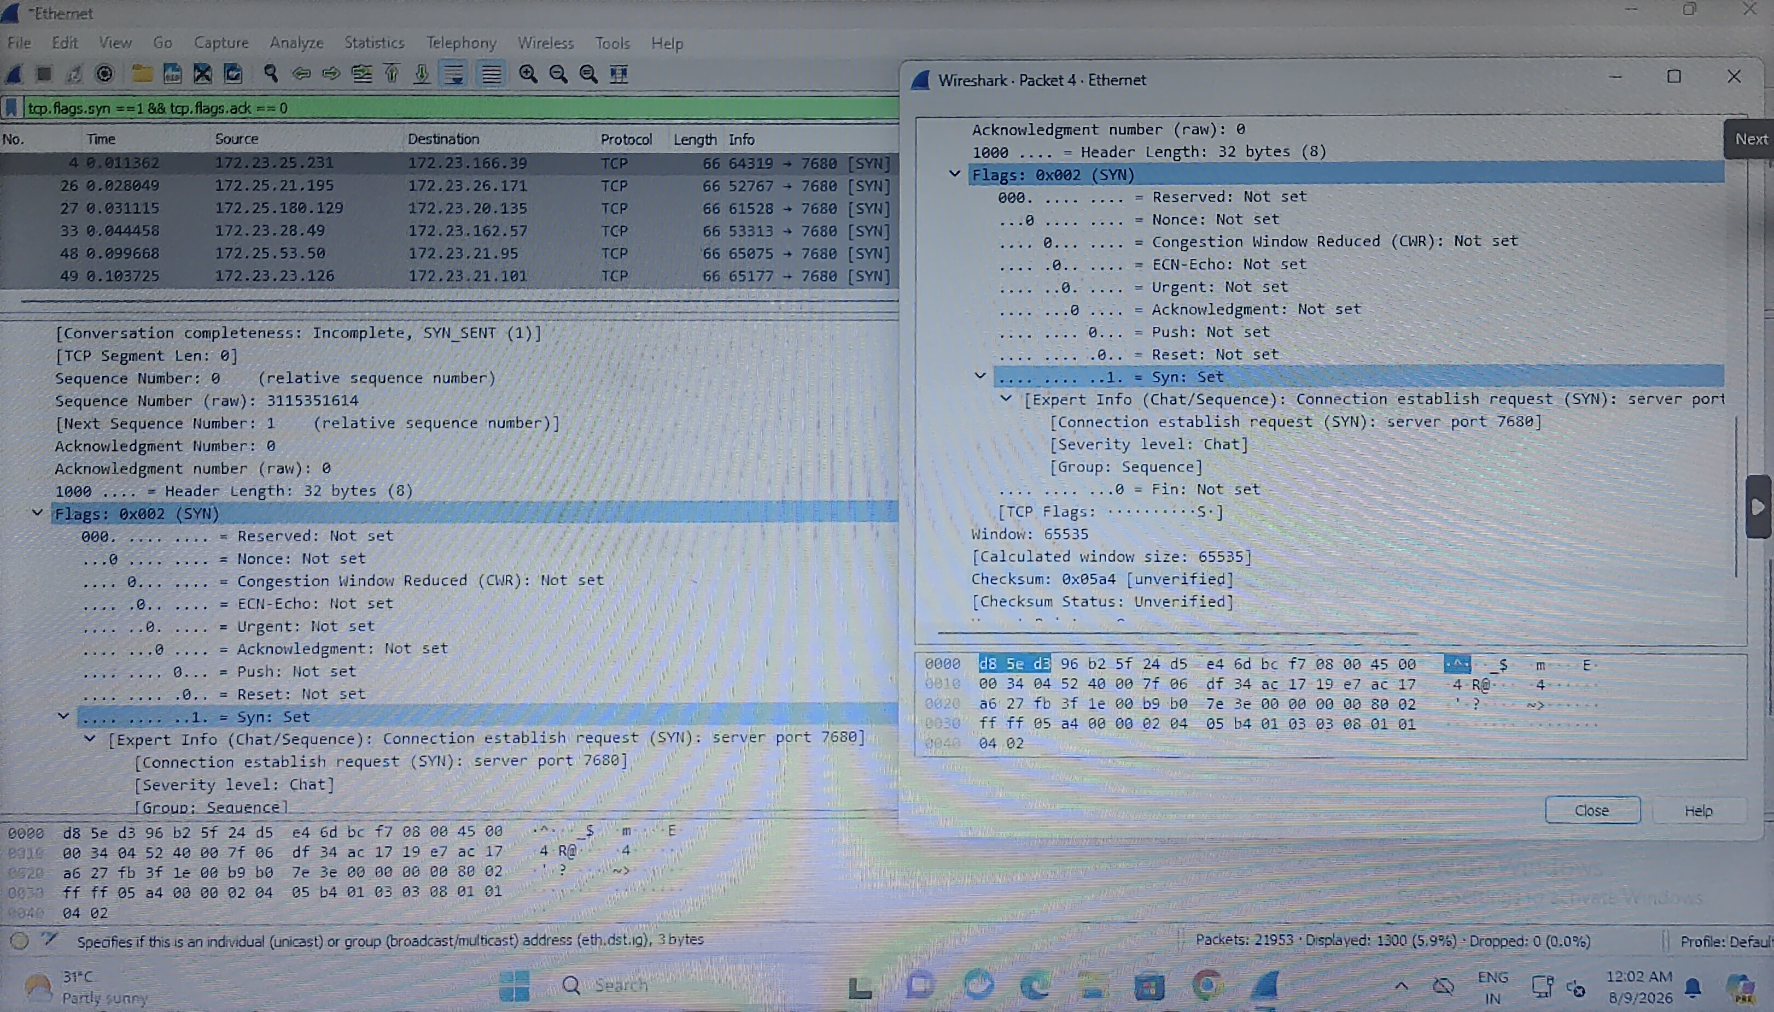

Question 3
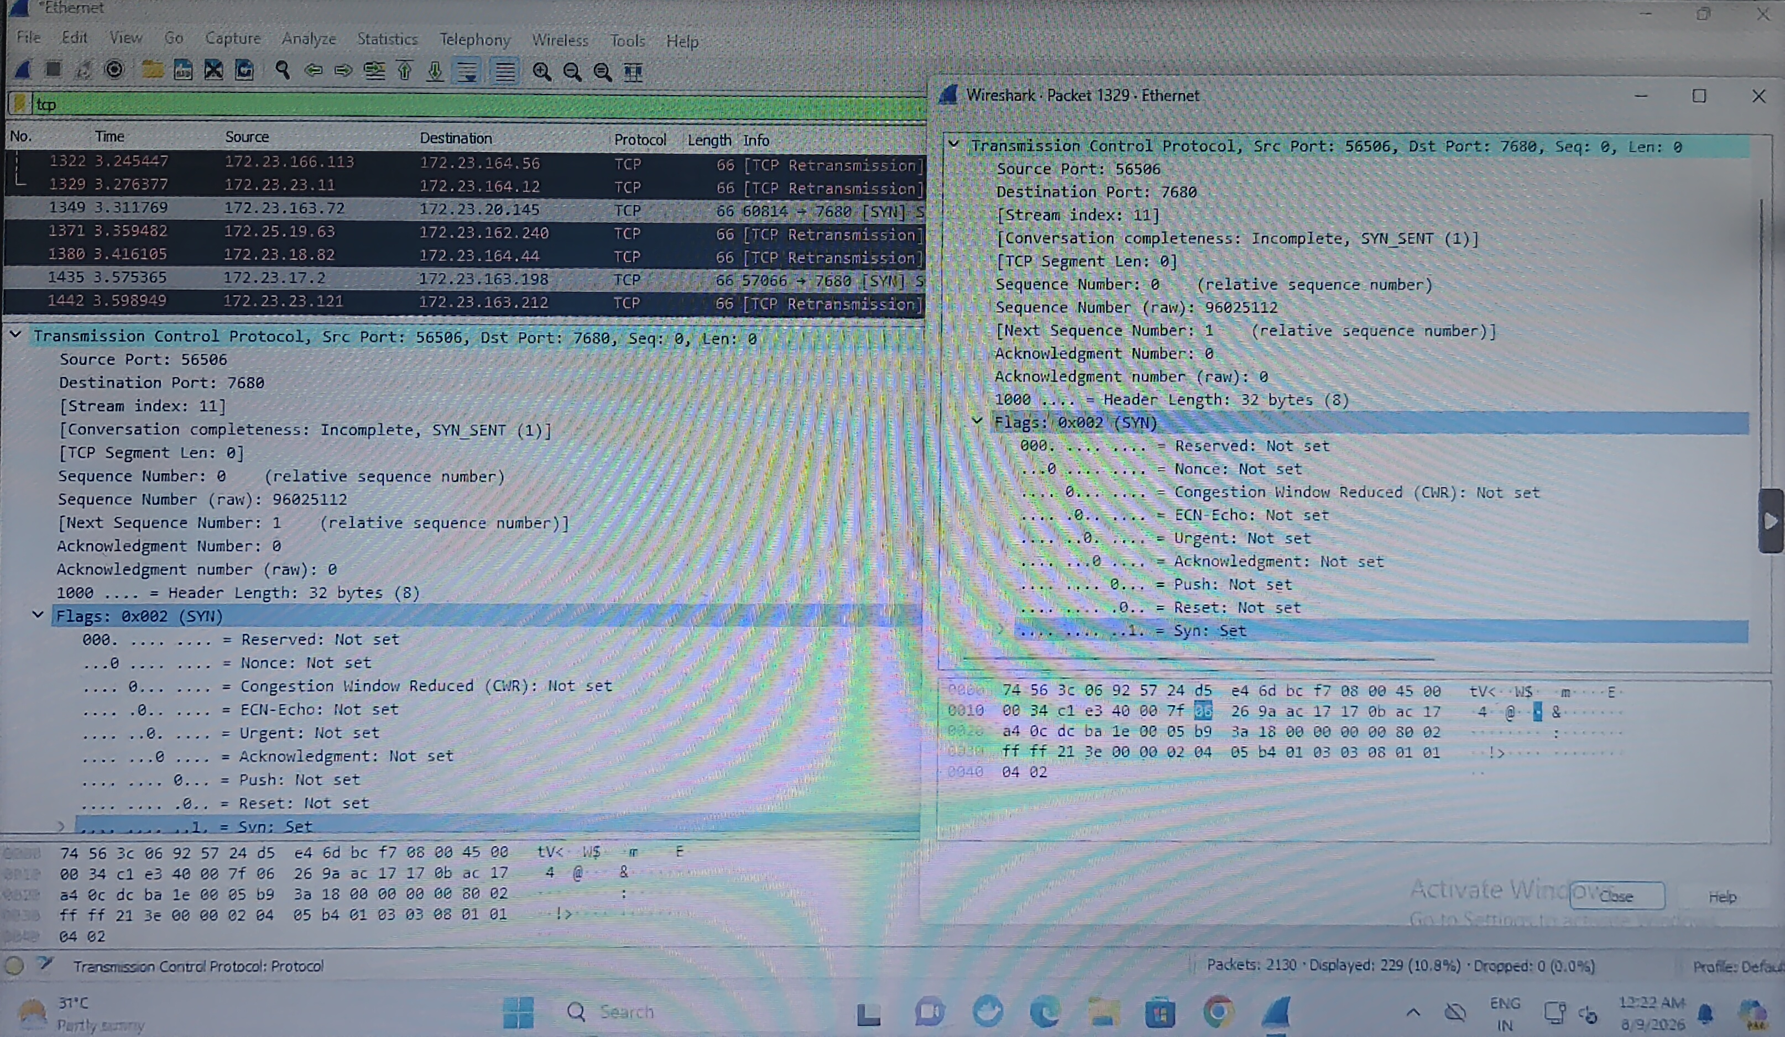

Question 4
